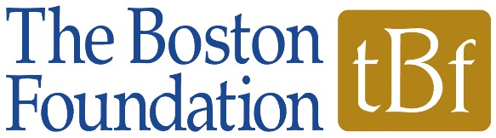

Request for Proposals:
The Latino Legacy Fund at the Boston Foundation

Project Narrative

Please be sure to review the Request for Proposals for full instructions. As a part of your application, your organization must complete an online form, as well as four attachments. For the Project Narrative attachment, please answer the following questions, in the order provided, in no more than four pages.

- Please provide a brief description of your organization, its mission (including the unmet need that your organization seeks to address), the population that you serve, and the programs and/or services you provide.

- Please describe your project. Please include in your description which focus area(s) of the Request for Proposals your project addresses (See RFP; e.g. ESOL programs focused on a specific career path, sector based incumbent worker training in growth industries, certificate and credentialing programs in high need occupations, etc.), and how your project aligns with the mission of the Latino Legacy Fund.

- What will happen over the next year? Please describe your goals and intended outcomes, including how many people will be impacted by your project over the grant period.

- How do you intend to achieve your intended outcomes? Please describe your activities, timeline for implementation, organizational resources and capacity, any relevant partnerships, etc.

- What does success for your project look like, how will your organization measure/evaluate its work, and what do you hope to learn?

- What will change because of your project? Please describe how you intend to sustain the work of your project beyond the grant term.

- Impact Story: Please share a brief story (200 words or less) about your organization, its programs or clients that illustrates its impact.

