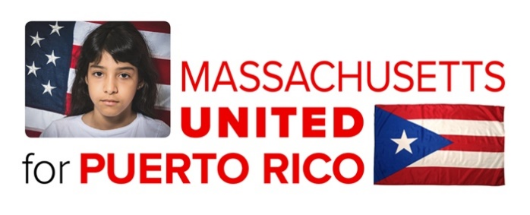

The Massachusetts United for Puerto Rico Fund
Request for Proposal for Relocation Funding

CONTACT INFORMATION
Organization:
Address:
Executive Director and contact information:
Contact for this proposal: |  |  |  |  |  | Title:
Phone: |  |  | Email:
Fax: |  |  | Website:

ORGANIZATION INFORMATION
Does the organization have US IRS 501(c)(3) status? |  |  |  | Yes |  |  | No
If no, please identify your fiscal agent or US intermediary:
Please attach a letter of agreement from your fiscal agent or intermediary supporting this application.
Briefly describe the mission and/or history of your organization in 3-4 sentences.
Is your organization Latino led? |  | Yes No
Total annual budget:
Total number of staff | Full time: |  |  | Part time:
Total number of Board members: |  |  |  | Total number of volunteers:
Have you previously applied for a grant with MUPR? Yes No
Have you spoken to a committee member before applying? Yes No
(PLEASE NOTE that it is not necessary to speak with someone before submitting your application.)
PROJECT INFORMATION
Project name: |  |  |  |  | Project location:  Western MA Central Ma  Greater Boston New Bedford  Other
Relocation project type: Advocacy Housing Health/Mental Health Workforce/Employment
Transportation School Food Assistance Resource Center
Other
Are you collaborating with other entities? Please check all that apply: Direct Service organizations Public agencies (please specify in question 5 below) Schools/school districts Organizations providing food assistance Housing organizations Health service organizations Workforce/Employment organizations
Transportation Services Other
Amount requested: Total Project budget (Range: $20,000-$50,000)
How many Puerto Rican evacuees are you serving currently?
Did these numbers change since September 2017? If so, please describe.
How are you currently assisting evacuees?
- Has your organization historically provided services to the Puerto Rican community in your area? If so, how?

- Please describe your project and expected outcomes. (Timelines, pending funding requests and/or other sources of funding)

- How will this grant help your project achieve its goals?

- Is this a project you have done before? If so, how is your current project similar or different?

- Please describe your collaboration with key partners in relation to this project.

- Do you have the capacity to document your history in serving evacuees from Puerto Rico? (e.g. data, family needs information, or school enrollment)

- Is there anything not covered in this RFP that you would like us to know?

Thank you for your time.

