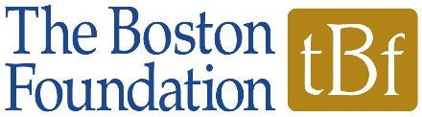  OUTCOMES CHART | This Outcomes Chart and the goals articulated here will serve as the basis of the annual reports that track progress on the goals of your grant. We consider your first submission of this Outcomes Chart to be a DRAFT. It will be the basis of dialog with your program officer who will help you revise it to reflect Long Term Goals that both your organization and TBF agree are ambitious, achievable and meaningful. The final version will be the basis of your award. With the agreement of your program officer, it may be updated prior to subsequent payments of multi-year awards.  Please note any areas in which you currently do not have the data to assess progress. Measures may be numerical (25 people served) or narrative (partnership agreement finalized). You may expand the size of the cells. Use NOTES to explain any changes in plans or activities.

Organization Name: | Grant #:
Program/Project Title: | Grant Period:
 | Report Date:

 | Long Term Goals | Activities | Indicators | Baseline | Desired Results | Results as of Report Date
 | What long term results do you want to achieve at the end of the grant period? | What are your plans or activities (program delivery and/or organizational capacity building) to achieve these goals? | What will you measure? | What is the current status of the activity? | What short term results do you want to see at the end of this grant year? | What results did you achieve this year?

1

2

3

NOTES:

